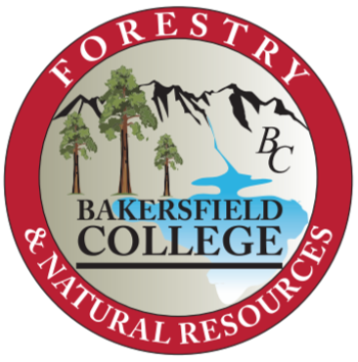

Proposed Forestry and Natural Resources Advisory Board

Brian Rueger- Forest Manager, Tule River Indian Reservation and Consulting Forester, Hammon, Jensen, Wallen & Associates
Julie Finzel- Animal Science and Rangeland Ecology and Management Advisor, UCANR
Len Nielson- Southern Region Forester II, CALFIRE
Brian Block- Ecosystem Manager, USFS- Sequoia National Forest, Kern River Ranger District
John Gomez- Forester, USFS- Sequoia National Forest, Kern River Ranger District
Joe Belli- Preserve Manager, Panorama Vista Preserve

jafinzel@ucanr.edu,brueger@ocsnet.net,len.nielson@fire.ca.gov,brian.block@usda.gov,john.gomez@usda.gov, joebelli@bak.rr.com

Meeting Agenda

- Introductions
- Introduction to Program
  - Club
  - Logging Sports
- Curriculum Review
  - New curriculum
  - SAF standards
- Field Sites Possibilities
- Workforce Development Possibilities/ Grants

Meeting Minutes

Introductions
- Program background
- Committee member introductions
Program Review
- Discussions for redevelopment of certificate program
  - Workforce needs
  - Shasta College- Licensed Timber Operator
- Incorporation of wildland fire program
- Technological needs
  - Drone
- Program name change- action word needed, fire/ management
- CEQA/ BMPs/ Regulations covered in program
- Jobs available/ level of education needed
- Rangeland- mostly transfer (looking into AS for TNC, NRCS)
Potential opportunities
- Scholarship Tulare/Sierra SAF
- Old CALFIRE decommissioned surplus equipment

